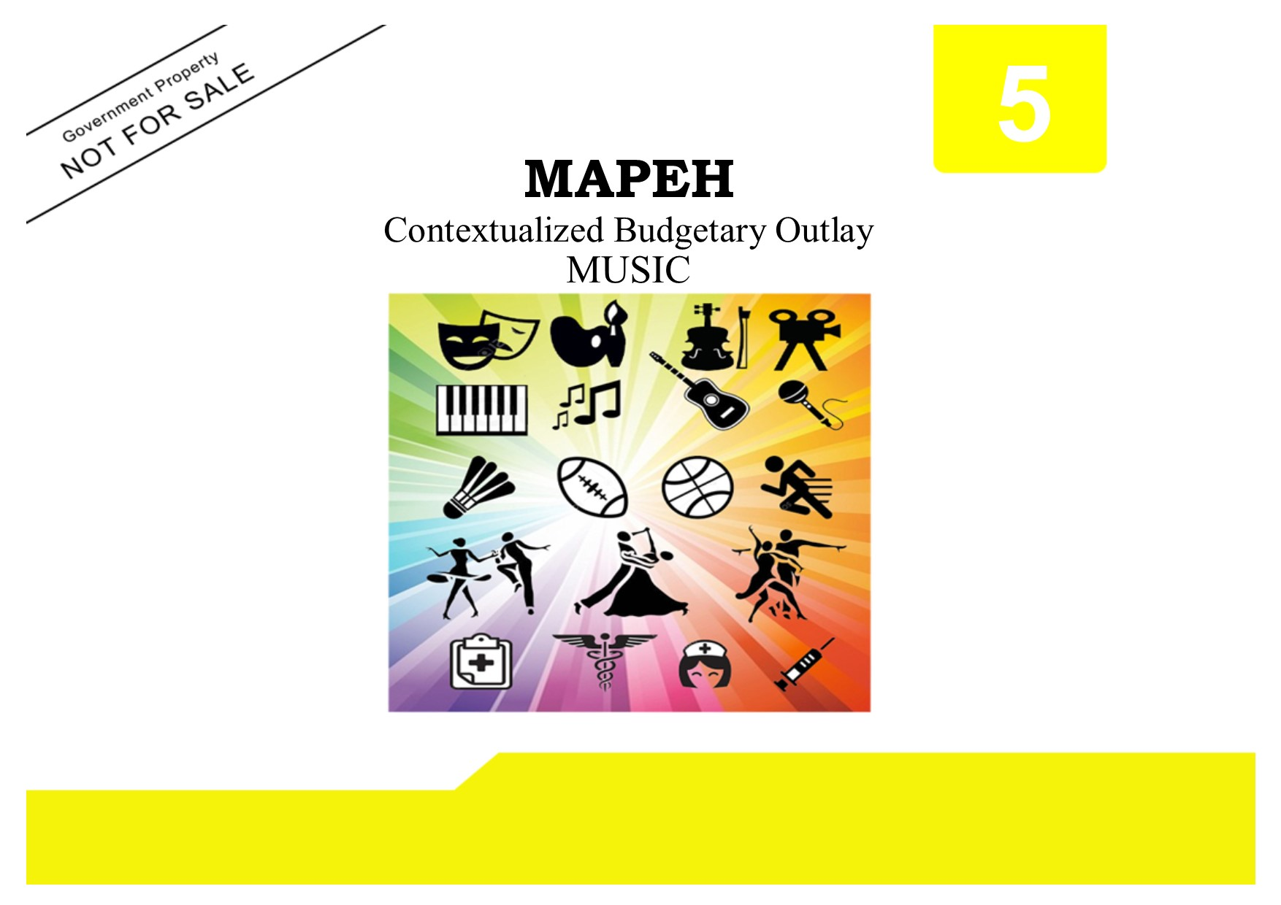

Copyright Page
Published by the
LEARNING RESOURCE MANAGEMENT AND DEVELOPMENT SYSTEM (LRMDS)
Department of Education
Region VI-Western Visayas
SCHOOLS DIVISION OF SILAY CITY
Silay City
Copyright 2019
Section 9 of Presidential Degree No. 49 provides
“No copyright shall subsist in any work of the Government of the Republic of the Philippines. However, prior approval of the government agency of office wherein work is created shall be necessary for exploitation of such work for profit.”
This budgetary outlay has been developed by the Curriculum and Implementation Division (CID) of the Department of Education, Schools Division of Silay City. It can be reproduced for educational purposes only. Derivatives of the work including creating an edited version, an enhancement or a supplementary work are permitted provided all original work is acknowledged and the copyright is attributed. No work may be derived from this material for commercial purposes and profit.

BUDGETARY OUTLAY IN MAPEH 5
Music
(Teacher’s Material)

Written by:

LENNY JOIE P. YASA

Illustrated by:

JERRY R. BAGUIOS

Quality Assured by:
CARMEL JOY P. AUJERO EVA G. TRABADO JOY P. NAKAMURA IVY PALLORINA ROWENA R. ESPARAGOZA
EPS-LRMDS EPS-MAPEH PDO II-LRMDS Division MAPEH Evaluator Division MAPEH Evaluator

Recommending Approval:
FEDERICO P. PILLON, JR.
CID Chief

Approved by:

CYNTHIA G. DEMAVIVAS, CESO V
Schools Division Superintendent

This first digital edition has been produced for print and online distribution within the Department of Education, Philippines via the Learning Resources (LR) Portal by the Schools Division of Silay City, deped.silay@deped.gov.ph
5
MAPEH
Contextualized Budgetary Outlay
MUSIC

This contextualized budgetary outlay was collaboratively developed and reviewed by educators from the Schools Division of Silay City. We encourage teachers to email their feedback, comments, and recommendations to the Schools Division of Silay City atdeped.silay@deped.gov.ph

We value your feedback and recommendations.

Schools Division of Silay City • Department of Education

BUDGETARY OUTLAY
MUSIC
GRADE V
FIRST GRADING
CONTENT STANDARDS | The learner recognizes the musical symbols and demonstrates understanding of concepts pertaining to rhythm.
PERFORMANCE STANDARDS | The learner performs with a conductor, a speech chorus in a simple time signatures  1.choral  2. instrumental

DAY | NO. OF DAYS | LEARNING COMPETENCIES | OBJECTIVES | SUBJECT MATTER | CODE | REFERENCE | MATERIALS
Day 1-2 | 2 | Identifies visually and aurally the kinds of notes and rests in a song | Natutukoy ang ibat ibang uri ng note at rest.  Naipakikita ang wastong beat ng note o rest sa pamamagitan ng pag awit o pagpalakpak. | Aralin 1:  Ang mga Note at Ang mga Rest | MU5RH- Ia-b-1 | TG pp 4 – 8  LM pp 2 - 9 | Flashcards ng mga nota at mga rest  Pictures  chart
Day 3-4 | 2 | Recognizes rhythmic patterns using quarter note, half note, dotted half note, dotted quarter note, and eight note in simple time signatures | Natutukoy ang ibat’ ibang rhythm at ibat’ ibang uri ng grupo ng pulso  Nakasusunod sa rhythmic pattern na itinakda sa pamamagitan ng pagpalakpak o pagtapik.  Nakabibigkas ng wasto ng mga syllable ng rhythmic pattern kasabay ng pagpalakpak o pagtapik sa wastong rhythm na itinakda | Aralin 2  Ang mga Rhythmic Pattern | MU5RH- Ia-b-2 | TG pp 8 – 11  LM pp 10-15 | Flashcards ng mga nota at mga rest  Pictures  chart

DAY | NO. OF DAYS | LEARNING COMPETENCIES | OBJECTIVES | SUBJECT MATTER | CODE | REFERENCE | MATERIALS
Day 5 | 1 | First Summative Test
Day 6-7 | 2 | Identifies accurately the duration of notes and rest in 2 3 4  4 , 4 ,4 time signatures | Nakikilala ang ibat ibang time signature.  Nakapagpapangkat-pangkat ng mga note at rest batay sa ibinigay na time signature.  Nakakukumpas ng isang awitin. | Aralin 3  Ang mga Time Signature | MU5RH-Ic-e-3 | TG pp 11 – 17  LM pp 16 - 23 | Chart Ng mga awiting Salidumay, Bahay Kubo, Wiyawi
Day 8 | 1 | Second Summative Test
Day 9 | 1 | Creates different rhythmic patterns using notes and rests in time signatures as : 2 3 4  4, 4, 4 | Nakabubuo ng rhythmic pattern gamit ang ibat ibang note at rest batay sa ibinigay na time signature. | Ang mga Time Signature | MU5RH-If-g-4 | TG pp 11 – 17  LM pp 16- 23 | Tsart ng mga awitin
Day 10 | 1 | Responds to metric pulses of music heard with appropriate conducting gestures | Nakakukumpas ng isang awitin. | Ang mga Time Signature | MU5RH-Ih-5 | TG pp 11 – 17  LM pp 16-23 | Charts  CD player
Day 11 | 1 | Performance Tasks
Day 12 | 1 | Third Summative Test

SECOND GRADING
CONTENT STANDARDS | Recognizes the musical symbols and demonstrates understanding of concepts pertaining to melody
PERFORMANCE STANDARDS | Accurate performance of songs following musical symbols pertaining to melody indicated in the piece

DAY | NO. OF DAYS | LEARNING COMPETENCIES | OBJECTIVES | SUBJECT MATTER | CODE | REFERENCE | MATERIALS
Day 1 | 1 | Recognizes the meaning and uses of F- Clef on the staff | Natutukoy ang iba’t- ibang simbolo ng musika. | Aralin 4  Ang Pagbabasa ng Note sa Piyesa | MU5ME-IIa-1 | TG pp20-29  LM pp24- 29 | Flash cards ng mga sibolo sa musika
Day 2 | 1 | Identifies the pitch names of each line and space on the F-Clef | Natutukoy at maaawit ang mga so-fa syllable gamit man o hindi ang mga hand sign.  Naaawit ang mga note na may accidentals | Ang Pagbabasa ng Note sa Piyesa | MU5ME- IIa-2 | TG pp 20-23  LM pp 24-27 | TSART different pitch names
Day 3 | 1 | Identifies the symbols: sharp (#) , flat (b), and natural | Nakikilala ang iba’t- ibang simbolo | Simbolo ng Musika | MU5ME- IIb-3 | TG pp 20-23  LM pp 28-29 | Flash cards ng mga  MUSICAL SYMBOLS
Day 4 | 1 | Recognizes aurally and visually, examples of melodic interval | Natutukoy ang ibat ibang interval sa musika at ang ugnayan nito sa melody. | Aralin 7  Ang mga Interval sa Musika | MU5ME-IIc-4 | TG pp 30 – 32  LM pp 44 – 49 | Tarp papel  Laptop  Bondpaper
Day 5 | 1 | First Summative Test
Day 6 | 1 | Identifies the notes of the intervals in the C major scale | Natutukoy ang scale at ang dalawang uri nito.  Nakabubuo ng dalawang major scale.  Naawit ng wasto ang mga major scale gamit ang mga so-fa syllable at mga hand signal. | Aralin 6  Ang mga Scale sa Musika | MU5ME-IIc-5 | TG pp 26-30  LM pp 36-39 | Tarp papel  Laptop

DAY | NO. OF DAYS | LEARNING COMPETENCIES | OBJECTIVES | SUBJECT MATTER | CODE | REFERENCE | MATERIALS
Day 7 | 1 | Identifies the successive sounding of two pitches | Naaawit ang ibat ibang intervals | Aralin 7  Ang mga uri ng Intervals | MU5ME-IId-6 | TG pp 30 – 35  LM pp 44 -49 | Charts  CD Player
Day 8 | 1 | Identifies the beginning melodic contour of a musical example | Natutukoy ang ibat ibang uri ng galaw,o direksiyon, range at distansiya nito. | Aralin 5  Ang Melodic Direction at Melodic Contour | MU5ME-IId-7 | TG pp 23-26  LM pp 30-33  Umawit at Gumuhit pp14-19 | Plaskard  Manila paper  Pentel Pen  Laptop
Day 9 | 1 | Second Summative Test
Day 10 | 1 | Determines the range of a musical example  *wide  *narrow | Naaawit ang mga note nang wasto ayon sa taas o baba nito gamit ang mga so-fa syllables. | Direksiyon at Sakop ng Melody | MU5ME-IIe-8 | TG pp 23-25  LM pp 30-33 | Tsart ng iba’t ibang awitin
Day 11 | 1 | Reads/sings notes in different scales  *Pentatonic scale  *C major scale  *G major scale | Naaawit ng wasto ang mga major scale gamit ang mga so-fa syllables at mga hand signs. | Mga Scale sa Musika | MU5ME-IIf-9 | TG pp 26- 30  LM pp 36-43 | Tsart ng Sofa Syllables at Scale
Day 12 | 1 | Creates simple melodies  Performs his/her own created melody | Nakabubuo ng sariling likhang may melodiya.  Naipakikita ang sariling galing. | Paggawa ng Proyekto | MU5ME-IIg-10  MU5ME-IIh-11 | TG pp 26- 30  LM pp 36-43 | Bondpaper  Pentel pen  Manila paper  Improvised instrument
Day 13 | 1 | Third Summative Test

THIRD GRADING
CONTENT STANDARDS | Demonstrate understanding of the uses and meaning of musical terms in form
PERFORMANCE STANDARDS | Perform the created song with appropriate musicality

DAY | NO. OF DAYS | LEARNING COMPETENCIES | OBJECTIVES | SUBJECT MATTER | CODE | REFERENCE | MATERIALS
Day 1 | 1 | Recognizes the design or structure of simple musical forms:  *unitary (one section)  *strophic ( same tune with two or more sections and 2 or more verses) | Natutukoy at Nakikilala ang pagkakaiba iba uri ng anyo ng musika.  Nakikilala ang pagkakaiba ng ibat ibang anyo ng musika sa pamamagitan ng pakikinig at pag aawit  . | Aralin 8  Ang Mga Anyo ng Musika | MU5FO-IIIa-1 | TG pp 38-41  LM pp 50-55 | Tsart ng mga  Awit  Manila paper  Pentel pen
Day 2 | 1 | Creates a 4-line unitary song | Nakabubuo ng 4 line unitary song. | Ang Mga Anyo ng Musika | MU5FO- IIIb-2 | TG pp 38-41  LM pp 50-55 | Manila paper  Pentel pen
Day 3 | 1 | Creates a 4-line strophic song with 2 sections and 2 verses | Nakabubuo ng 4 line strophic song na may dalawang bahagi at dalawang saknong. | Ang Mga anyo ng Musika | MU5FO-IIIc-d-3 | TG pp 38-41  LM pp 50-55 | Bond paper  ballpen  Manila paper  Pentel pen
Day 4 | 1 | First Summative Test

CONTENT STANDARDS |  |  | Demonstrate understanding of variations of sound density in music (lightness and heaviness) as applied to vocal and instrumental music
PERFORMANCE STANDARDS |  |  | Participates in group performance to demonstrate different vocal and instrumental sounds
DAY | NO. OF DAYS | LEARNING COMPETENCIES |  | OBJECTIVES | SUBJECT MATTER | CODE | REFERENCE | MATERIALS
Day 5 | 1 | Describes the characteristic of each type of voice |  | Natutukoy ang timbre at ang ibat ibang uri nito. | Aralin 9  Timbre: Tinig sa Pag- awit | MU5TB-IIIe-1 | TG pp. 41-44  LM pp. 56-63 | CD tape, speaker

DAY | NO. OF DAYS | LEARNING COMPETENCIES | OBJECTIVES | SUBJECT MATTER | CODE | REFERENCE | MATERIALS
Day 6 | 1 | Identifies the following vocal timbres:  * soprano  * alto  *tenor  *bass | Nakikilala ang iba’t- ibang uri ng timbre sa pag awit sa pamamagitan ng pakikinig at pag awit. | Timbre Tinig sa Pag- awit | MU5TB-IIIe-2 | TG pp 41-44  LM pp 56-63 | CD tape  Speaker  audio visual  audio recordings
Day 7 | 1 | Second Summative Test
Day 8 | 1 | Identifies aurally and visually different instruments in :  *rondalla  *drum and lyre band  *bamboo group ensemble  ( Pangkat kawayan)  *other local indigenous ensembles | Natutukoy ang mga instrumento na kabilang sa rondalya, bandang drum at lyre.  Nakatutugtog mg isang instrumento na kabilang sa rondalla o bandang drum at lyre | Aralin 10  Ang Rondalya At Ang Bandang Drum at Lyre | MU5TB-IIIf-3 | TG pp 44-47  LM pp 64-71 | Larawan  Tsart  Improvised materials from localized materials
Day 9 | 1 | Creates variety of sounds emanating from the environment using available sound source | Nakabubuo ng pangkat ng mga instrumento mula sa mga bagay na makikita sa kapaligiran. | Project making | MU5TB-III g-h-5 | TG pp 44-47  LM pp 64-70 | Can, gallon, mineral/bote, sticks/Maracastansan
Day 10-11 | 1 | Participates actively in musical ensemble  *choral  * instrumental | Naipapakita ang galing sa sabayang pag-awit ( rhythm band) | Performance output | MU5TB-IIIg-4 | TG pp 44-47  LM pp 64-70 | CD tape/ sound recordings  speaker
Day 12 | 1 | Third Summative Test

FOURTH GRADING
CONTENT STANDARDS | Demonstrates understanding of concepts pertaining to volume in music
PERFORMANCE STANDARDS | Applies dynamics to musical selections

DAY | NO. OF DAYS | LEARNING COMPETENCIES | OBJECTIVES | SUBJECT MATTER | CODE | REFERENCE | MATERIALS
Day 1 | 1 | Identifies the different dynamic levels used in a song heard | Natutukoy ang iba’t- ibang uri ng Dynamics | Aralin 12  Mga Antas ng Dynamics | MU5DY- IVa-b-1 | TG pp 55-57  LM pp. 78-83 | Tsart
Day 2 | 1 | Uses appropriate musical terminology to indicate variations in dynamics, specially:  *piano (p)  *mezzo piano (mp)  *forte (f)  *mezzo forte (mf)  *crescendo  *decrescendo | Nakikilala ang iba’t -ibang uri ng Dynamics. | Mga Antas ng Dynamics | MU5DY- IVa-b-2 | TG pp 55-57  LM pp 78-81 | Flash cards  Tsart  Manila paper  Pentel pen
Day 3 | 1 | First Summative Test

CONTENT STANDARDS |  |  | Recognizes the musical symbols and demonstrate understanding of concepts pertaining to speed in music
PERFORMANCE STANDARDS |  |  | Applies appropriately, various tempo to vocal and instrumental performances.
DAY | NO. OF DAYS | LEARNING COMPETENCIES |  | OBJECTIVES | SUBJECT MATTER | CODE | REFERENCE | MATERIALS
Day 4 | 1 | Identifies the various tempo used in a song heard |  | Natutukoy ang iba’t ibang uri ng tempo. | Ang Tempo | MU5TP- IVc- 1 | TG pp 58-61  LM pp 84-87 | CD SPEAKER

DAY | NO. OF DAYS | LEARNING COMPETENCIES | OBJECTIVES | SUBJECT MATTER | CODE | REFERENCE | MATERIALS
Day 5 | 1 | Uses appropriate musical terminology to indicate variations in tempo:  *largo  *presto  *allegro  *moderato  *andante  *vivace  *ritardando  *accelerando | Nakikilala ang kaibahan ng ibat ibang uri ng tempo. | Tempo | MU5TP- IVc- d-2 | TG pp 58-61  LM pp 84-87 | Charts  CD player  SPEAKER
Day 6 | 1 | Second Summative Test

CONTENT STANDARDS | Demonstrates understanding of concepts pertaining to texture in music
PERFORMANCE STANDARDS | Recognizes examples of horizontal 3-part vocal or instrumental texture, aurally and visually

DAY | NO. OF DAYS | LEARNING COMPETENCIES | OBJECTIVES | SUBJECT MATTER | CODE | REFERENCE | MATERIALS
Day 7 | 1 | Identifies aurally the musical texture of musical piece | Natutukoy at nakikilala ang iba’t ibang uri ng texture. | Ang Texture | MU5TX- IVe- 1 | TG pp 61-63  LM pp 88- 93 | Speaker  CD player
Day 8 | 1 | Performed 3-part rounds and partner songs. | Naipakikita ang galing sa 3-part round | Performance Output | MU5TX- IVe- 2 |  | Speaker  Sound  CD

CONTENT STANDARDS | Recognizes the musical symbols and demonstrates understanding of harmonic intervals
PERFORMANCE STANDARDS | Performs a vocal or instrumental ensemble using the following major triads ( I, IV, V)

DAY | NO. OF DAYS | LEARNING COMPETENCIES | OBJECTIVES | SUBJECT MATTER | CODE | REFERENCE | MATERIALS
Day 9-10 | 2 | Identifies the intervals of the following major triads:  *tonic (I)  *subdominant (IV)  *dominant (V) | Naipag-iisaisa ang iba’t ibang intervals:  *tonic (I)  *subdominant (IV)  *dominant (V) | Ang Harmony | MU5HA-IV f-g-1 | TG pp 63- 69  LM pp94- 100 | Manila paper  Pentel pen  So-Fa Syllable Chart
Day 11 | 1 | Uses the major triad as accompaniment to simple songs | Nakabubuo ng Scale at makaguguhit ng Primary Chord | Ang Harmony | MU5HA-IV h-2 | TG pp 63- 69  LM pp94- 100 | Speaker  CD  Bond paper  Manila paper  Pentel pen
Day 12 | 1 | Third Summative Test

