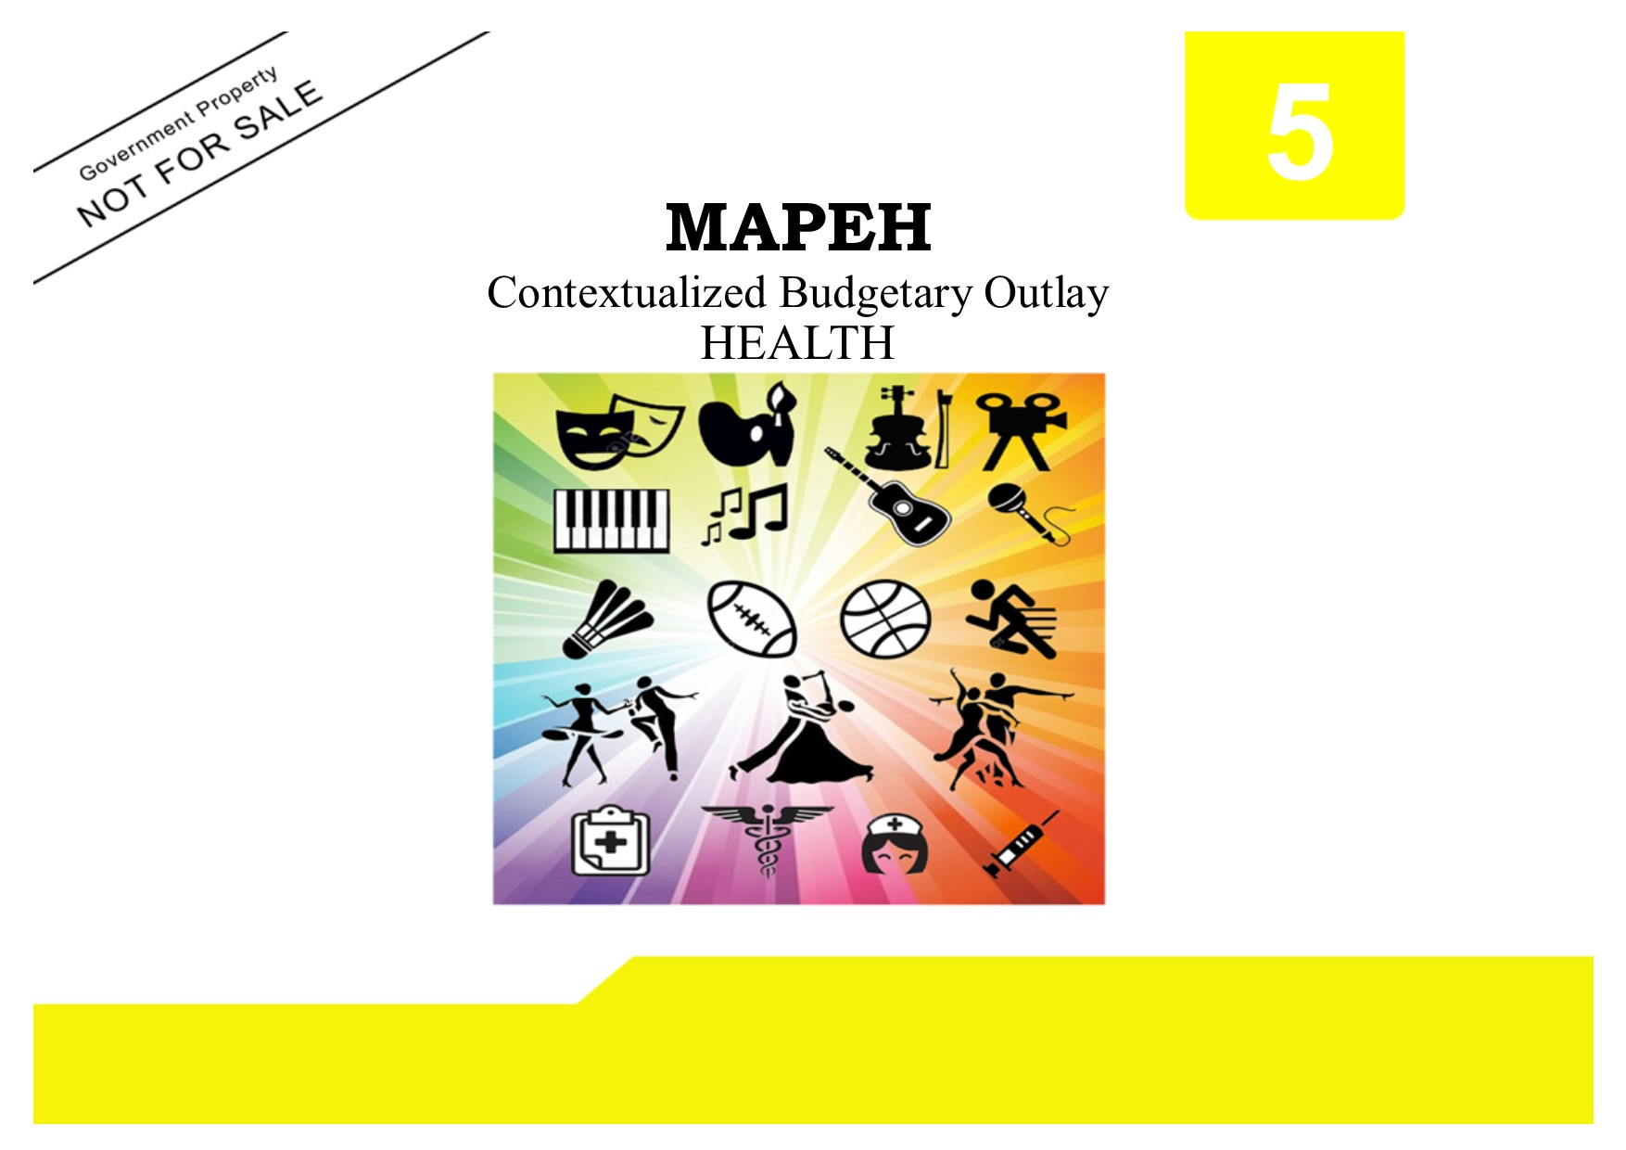

Copyright Page
Published by the
LEARNING RESOURCE MANAGEMENT AND DEVELOPMENT SYSTEM (LRMDS)
Department of Education
Region VI-Western Visayas
SCHOOLS DIVISION OF SILAY CITY
Silay City
Copyright 2019
Section 9 of Presidential Degree No. 49 provides
“No copyright shall subsist in any work of the Government of the Republic of the Philippines. However, prior approval of the government agency of office wherein work is created shall be necessary for exploitation of such work for profit.”
This budgetary outlay has been developed by the Curriculum and Implementation Division (CID) of the Department of Education, Schools Division of Silay City. It can be reproduced for educational purposes only. Derivatives of the work including creating an edited version, an enhancement or a supplementary work are permitted provided all original work is acknowledged and the copyright is attributed. No work may be derived from this material for commercial purposes and profit.

BUDGETARY OUTLAY IN MAPEH 5
Health
(Teacher’s Material)

Written by:

LILIBETH A. LORO

Illustrated by:

JERRY R. BAGUIOS

Quality Assured by:
CARMEL JOY P. AUJERO EVA G. TRABADO JOY P. NAKAMURA IVY PALLORINA ROWENA R. ESPARAGOZA
EPS-LRMDS EPS-MAPEH PDO II-LRMDS Division MAPEH Evaluator Division MAPEH Evaluator

Recommending Approval:
FEDERICO P. PILLON, JR.
CID Chief

Approved by:

CYNTHIA G. DEMAVIVAS, CESO V
Schools Division Superintendent

This first digital edition has been produced for print and online distribution within the Department of Education, Philippines via the Learning Resources (LR) Portal by the Schools Division of Silay City, deped.silay@deped.gov.ph
5
MAPEH
Contextualized Budgetary Outlay
HEALTH

This contextualized budgetary outlay was collaboratively developed and reviewed by educators from the Schools Division of Silay City. We encourage teachers to email their feedback, comments, and recommendations to the Schools Division of Silay City atdeped.silay@deped.gov.ph

We value your feedback and recommendations.

Schools Division of Silay City • Department of Education

BUDGETARY OUTLAY
HEALTH
GRADE V
FIRST GRADING
CONTENT STANDARDS | Demonstrates understanding of mental, emotional, and social health concerns.
PERFORMANCE STANDARDS | Practices skills in managing mental, emotional and social health concerns

DAY | NO. OF DAYS | LEARNING COMPETENCIES | OBJECTIVES | SUBJECT MATTER | CODE | REFERENCE | MATERIALS
Day 1 | 1 | Describes a mentally, emotionally and socially healthy person | Nailalarawan ang taong malusog ang pangangatawan at maayos na kalagayan ng mental, at sosyal | Mental, Emosyonal, at Sosyal na Kalusugan | H5PH-Iab-10 | Masigla at Malusog na Katawan at Isipan 5  TG pp 55 – 58  LM pp 121-125 | Larawan  Tsart  Makulay na papel
Day 2 | 1 | Suggests ways to develop and maintain one’s mental and emotional health | Naimumungkahi ang mga paraan ng pagpa-panatili ng kalusugan mental, emosyonal, at sosyal |  | H5PH – Ic – 11 | K to 12 Curriculum Guide p 47 | Larawan  Tsart  Makulay na papel
Day 3 | 1 | Recognizes signs of healthy and unhealthy relationships | Nakikilala ang mga palatandaan ng malusog at hindi malusog na relasyon | Malusog at Hindi Malusog na Relasyon | H5PH–Id–I2 | Masigla at Malusog na Katawan at Isipan 5  TG pp 59 - 62  LM pp. 126-131 | Video clips  Tsart

DAY | NO. OF DAYS | LEARNING COMPETENCIES | OBJECTIVES | SUBJECT MATTER | CODE | REFERENCE | MATERIALS
Day 4 | 1 | Explains how healthy relationships can positively impact health | Naipaliliwanag ang mga positibong epekto sa kalusugan ng pagkakaroon ng malulusog na relasyon |  | H5PH–Ie–I3 | K to 12 Curriculum Guide p 47  TG pp 59-62  LM pp 126-131
Day 5 | 1 | Discusses ways of managing unhealthy relationships | Natatalakay ang mga paraan ng pamamahala sa mga hindi malusog na relasyon |  | H5PH–If–I4
Day 6 | 1 | Describes some mental, emotional and social health concerns | Nailalarawan ang ilang alalahaning mental, emosyonal, at sosyal | Mga Alalahaning Mental, Emosyonal at Sosyal | H5PH–Ig–I5 | Masigla at Malusog na Katawan at Isipan 5  TG pp 62 - 65  LM pp 132-139 | Video clips  Tsarts
Day 7-8 | 2 | Discusses the effects of mental, emotional and social health concerns on one’s health and wellbeing | Natatalakay ang mga epekto sa kalusugan ng mga alalahaning mental, emosyonal, at sosyal |  | H5PH–Ih–I6 | K to 12 Curriculum Guide p 47-48
Day 9-10 | 2 | Demonstrates skills in preventing or managing teasing, bullying, harassment or abuse | Naipamamalas ang kakayahang masupil at pamahalaan ang bullying, panunukso, harassment, at pang-aabuso | Paghahadlang at Pangangasiwa sa mga Alalahaning Mental, Emosyonal, at Sosyal | H5PH–Ii–I7 | Masigla at Malusog na Katawan at Isipan 5  TG pp 66 – 69  LM pp 140-144

DAY | NO. OF DAYS | LEARNING COMPETENCIES | OBJECTIVES | SUBJECT MATTER | CODE | REFERENCE | MATERIALS
Day 11-12 | 2 | Identifies appropriate resources and people who can help in dealing with mental, emotional and social, health concerns | Natutukoy ang mga tao at bagay- bagay na maaaring makatulong sa mga alalahaning mental, emosyonal, at sosyal | Paghahadlang at Pangangasiwa sa mga Alalahaning Mental, Emosyonal, at Sosyal | H5ph–Ij–I8 | K to 12 Curriculum Guide p 48 | Video clips  Tsart
Day 13 | 1 | Summative Test/Periodical Test

SECOND GRADING
CONTENT STANDARDS | Demonstrates understanding of mental, emotional, and social health concerns.
PERFORMANCE STANDARDS | Practices skills in managing mental, emotional and social health concerns

DAY | NO. OF DAYS | LEARNING COMPETENCIES | OBJECTIVES | SUBJECT MATTER | CODE | REFERENCE | MATERIALS
Day 1 | 1 | Describes the physical, emotional and social changes during puberty | Nailalarawan ang mga  pagbabagong pisikal,  emosyonal, at sosyal  na mararanasan  habang nagbibinata at  nagdadalaga | Mga Pababago sa Katawan sa Panahon ng Pagbibinata at Pagdadalaga | H5GD–Iab–1 | Masigla at Malusog na Katawan at Isipan 5,  TG pp 73 – 75  LM pp 146- 155 | Larawan  Tsart
Day 2 | 1 | Accepts changes as a normal part of growth and development | Natatanggap ang mga pagbabagong ito bilang bahagi ng paglaki at pagtanda |  | H5GD–Iab-2 | K to 12 Curriculum Guide p 48
Day 3 | 1 | Describes common misconceptions related on puberty  Assesses the issues in terms of scientific basis and probable effects on health | Nailalarawan ang mga maling paniniwala tungkol sa puberty  Nasusuri ang mga  isyu ayon sa pagka-  karoon ng medikal at  siyentipikong batayan | Mga Paniniwalang may Kinalaman sa Pagbibinata at Pagdadalaga | H5GD–Icd–3 | Masigla at Malusog na Katawan at Isipan 5,  TG pp 75 – 77  LM pp 156-159  K to 12 Curriculum Guide p 49 | Larawan  Tsart

DAY | NO. OF DAYS | LEARNING COMPETENCIES | OBJECTIVES | SUBJECT MATTER | CODE | REFERENCE | MATERIALS
Day 4 | 1 | Describes the common health issues and concerns during puberty | Nailalarawan ang mga  karanasang isyung  pangkalusugang  nararanasan sa  panahon ng puberty | Mga Isyung Pangkalusugan Kaakibat ng Pagbibinata at Pagdadalaga | H5GD–Ief–5 | Masigla at Malusog na Katawan at Isipan 5,  TG pp 77 - 79  LM pp 162 - 171 | Mga kagamitan sa pangangalaga ng katawan
Day 5 | 1 | Accepts that most of these concerns are normal consequence of bodily changes during puberty but one can learn to manage them | Natatanggap na karamihan sa mga  isyung ito ay normal na pinag-dadaan sapanahon ng puberty at maaaring matutuhang pamahalaan | Mga Isyung Pangkalusugan Kaakibat ng Pagbibinata at Pagdadalaga | H5GD–Ief–6 | Masigla at Malusog na Katawan at Isipan 5,  TG pp 77 - 79  LM pp 162 - 171 | Mga kagamitan sa pangangalaga ng katawan
Day 6 | 1 | Demonstrates empathy for persons undergoing these concerns and problems | Naipamamalas ng pag-iintindi at pakikisama sa mga taong nakararanas ng mga isyung ito |  |  | H5GD–Igh -7
Day 7 | 1 | Discusses the negative health impact and ways of preventing major issues such as early and unwanted pregnancy | Natatalakay ang masasamang epekto ng maagang pagbubuntis at paano ito maiiwasan |  |  | H5GD–Igh-8
Day 8 | 1 | Demonstrates ways to manage puberty-related health issues and concerns  Practices proper self-care procedures | Naipamamalas ng tamang pamamahala ng mga isyung pangkalusugan dulot ng puberty  Naisasagawa ng tamang pangangalaga sa sarili at sa kalusugan | Mga Usapin Tungkol sa Kasarian at Seksuwalidad | Masigla at Malusog na Katawan at Isipan 5,  TG pp 79 – 82  LM pp 174-179  K to 12 Curriculum Guide) p 50 | H5GD–Ii–9  H5GD–Ii–10 | Mga kagamitan sa paglilinis ng katawan

DAY | NO. OF DAYS | LEARNING COMPETENCIES | OBJECTIVES | SUBJECT MATTER | CODE | REFERENCE | MATERIALS
Day 9 | 1 | Discusses the importance of seeking the advice of professionals/ trusted and reliable adults in managing puberty-related health issues and concerns | Natatalakay ang kahalagahan ng paghingi ng payo at tulong sa mga propesyonal at mga nakatatandang mapagkatitiwalaan | Mga Usapin Tungkol sa Kasarian at Seksuwalidad | H5GD–Ii–11 | Masigla at Malusog na Katawan at Isipan 5,  TG pp 79 – 82  LM pp 174-179  K to 12 Curriculum Guide) p 50 | Mga kagamitan sa paglilinis ng katawan
Day 10 | 1 | Differentiates sex from gender  Identifies factors that influence gender identity and gender roles | Natutukoy ang kaibahan ng kasarian sa seksuwalidad  Natutukoy ang mga salik na nakaka-impluwensya sa seksuwalidad na pagkakakilanlan at kasariang pamantayan | Kasarian at Seksuwalidad at mgaTungkuling Kaakibat Nito | H5GD–Ij–12  H5GD–Ij– 13 | LM Health Grade 5,  LM pp 174– 179 | Video clips  Tsart
Day 11 | 1 | Discusses how family, media, religion, school and society in general reinforce gender roles | Natatalakay kung paano ang pamilya, medya, relihiyon, paaralan at pamayanan sa kabuluhan na nakakatulong sa kasariang pamantayan |  | H5GD–Ij– 14
Day 12 | 1 | Gives examples of how male and female gender roles are changing | Nakapagbibigay ng mga halimbawa na ang pambabae at panlalaking kasariang pamantayan ay nagbabago |  | H5GD–Ij– 15
Day 13 | 1 | Summative Test/Periodical Test

THIRD GRADING
CONTENT STANDARDS | Understands the nature and effects of the use and abuse of caffeine, tobacco and alcohol
PERFORMANCE STANDARDS | Demonstrates the ability to protect one’s health by refusing to use or abuse gateway drugs

DAY | NO. OF DAYS | LEARNING COMPETENCIES | OBJECTIVES | SUBJECT MATTER | CODE | REFERENCE | MATERIALS
Day 1-2 | 2 | Explains the concept of gateway drugs | Naipaliliwanag ang mga katangian ng gateway drugs | Mga katangiaan ng Drogang Gateway: Caffeine, Tabako at  Alkohol | H5SU–IIIa–7 | Masigla at Malusog na Katawan at Isipan 5  TG pp 87 – 90  LM pp 181 – 185 | Larawan  Tsart  Kartolina  Panulat
Day 3 | 1 | Identifies products with caffeine | Natutukoy ang mga produkto, may pagkain, at inuming may caffeine |  | H5SU–IIIb– 8
Day 4-5 | 2 | Discusses the nature of caffeine, nicotine and alcohol use and abuse | Natatalakay ang mga paraan ng paggamit at pag-aabuso sa may caffeine, tabako, alcohol |  | H5SU–IIIc–9
Day 6-7 | 2 | Describes the general effects of the use and abuse of caffeine, tobacco and alcohol | Nailalarawan ang mga pangkalahatang epekto ng paggamit at pag-aabuso sa caffeine, tabako, alcohol | Epekto ng sobrang Pagamit ng mga Drogang Gateway | H5SU–IIIde-10 | Masigla at Malusog na Katawan at Isipan 5,  TG pp 90- 93  LM pp 186 – 191  K to 12 Curriculum Guide p 51 | Larawan  Video clips  Tsart  Kartolina  Panulat

DAY | NO. OF DAYS | LEARNING COMPETENCIES | OBJECTIVES | SUBJECT MATTER | CODE | REFERENCE | MATERIALS
Day 8-9 | 2 | Analyzes how the use and abuse of caffeine, tobacco and alcohol can negatively impact the health of the individual, the family and the community | Nasusuri ang mga negatibong epekto ng paggamit at pag-abuso ng caffeine, tabako, at alcohol | Kahihinatnan at ng Paggamit at Pag-aabuso sa Gateway Drugs | H5SU–IIIfg-11 | Masigla at Malusog na Katawan at Isipan 5, TG pp 94-97  LM pp 192-195  K to 12 Curriculum Guide p 52 | Larawan/video clips  Tsart  Catolina  panulat
Day 10 | 1 | Demonstrates life skills in keeping healthy through the non-use of gateway drugs | Naipamamalas ang kakayahang manatiling malusog sa pamamagitan ng pag-iwas sa paggamit at pag-abuso sa caffeine, tabako, at alak | Pagpigil at Pag-iwas sa Pang-aabuso ng Drogang  Gateway | H5SU–IIIh-12 | Masigla at Malusog na Katawan at Isipan 5,  TG pp 97 - 101  LM pp 196 - 199 | Larawan  Tsart  Cartolina  Panulat
Day 11-12 | 2 | Follows school policies and national laws related to the sale and use of tobacco and alcohol | Nakasusunod sa mga batas at alituntunin sa pagbebenta at pag-gamit ng tabako at alak |  | H5SU-IIIij-13 | K to 12 Curriculum Guide p 52
Day 13 | 1 | Summative Test/Periodical Test

FOURTH GRADING
CONTENT STANDARDS | Demonstrates understanding of basic first aid principles and procedures for common injuries
PERFORMANCE STANDARDS | Practices appropriate first aid principles and procedures for common injuries

DAY | NO. OF DAYS | LEARNING COMPETENCIES | OBJECTIVES | SUBJECT MATTER | CODE | REFERENCE | MATERIALS
Day 1 | 1 | Explains the nature and objectives of first aid | Naipaliliwanag ang kahulugan ng pangunang lunas | Mga Katangian at Layunin ng Pangunang Lunas | H5IS–IVa–34 | Masigla at Malusog na Katawan at Isipan 5  TG pp 103– 106  LM pp 201 - 203  K to 12 Curriculum Guide  P 52  Masigla at Malusog na Katawan at Isipan 5  TG pp 106 – 109  LM pp 204 - 208 | Larawan  Tsart  Kartolina  Panulat
Day 2 | 1 |  | Natutukoy ang mga katangian ng pangunahing lunas
Day 3 | 1 |  | Natutukoy at na ipaliwanag ang mga layunin ng pangunahing lunas

DAY | NO. OF DAYS | LEARNING COMPETENCIES | OBJECTIVES | SUBJECT MATTER | CODE | REFERENCE | MATERIALS
Day 4 | 1 | Discusses the basic first aid principles | Natutukoy ang mga panuntunan ng pangunang lunas | Panuntunan ng Pangunang Lunas | H5IS–IVb–35 | Masigla at Malusog na Katawan at Isipan 5  TG pp 106 – 109  LM pp 204 - 208 | Larawan  Tsart  Kartolina  Panulat
Day 5 | 1 |  | Naipaliliwanag ang kahalagahan ng mga panuntunan ng pangunang lunas |  |  | K to 12 Curriculum Guide  P 52
Day 6 | 1 |  | Nasususnod at naipatututpad ang mga panuntunan ng pangunang lunas
Day 7-8 | 2 | Demonstrates appropriate first aid for common injuries or condition | Natutukoy ang mga karaniwang pinsala at kondisyon nangangailangan ng pangunang lunas | Pangunang Lunas para sa mga Karaniwang Pinsala at Kondisyon | H5IS–IV-c–j -36 | Masigla at Malusog na Katawan at Isipan 5  TG pp 109 - 111  LM pp 208 – 213  K to 12 Curriculum Guide p.53 | Larawan  Tsart  Kartolina  panulat
Day 9-10 | 2 |  | Naipapamalas ang nararapat na pangu-nang lunas para sa mga ito
Day 11 | 1 | Performance Task
Day 12 | 1 | Summative Test/Periodical Examination

